**IPT102 - INTEGRATIVE PROGRAMMING AND TECHNOLOGIES 2**

**MIDTERM LABORATORY EXAM**

**NAME: Lazaro, Jaymarc D.**

**PERCENTAGE**

**SCORE**

**STUDENT NO: 20-1436**

**YEAR/SECTION: SBIT-3L**

**DATE: 10/15/2022**

*Rubric:*

|  |  |  |  |  |
| --- | --- | --- | --- | --- |
| Criteria | Excellent  (25 pts.) | Good  (20 pts) | Fair  (15 pts.) | Poor  (0 pt.) |
| **Program Execution** | Program executes correctly with no syntax or runtime errors. | Program executes with minor(easily fixed errors). | Program executes with minor(not easily fixed errors. | Program does not executes. |
| **Correct Output** | Program displays correct output with no errors. | Output has minor errors. | Output has multiple errors. | Output is incorrect. |
| **Code Construction** | Program is statistically well designed. | Few inappropriate design choices(i.e. poor variable names and algorithm) | Several inappropriate design choices(i.e. poor variable names and algorithm) | Program is poorly written |
| **Page Layout and Design** | Forms, text and images laid out on the page in a well balanced manner. | The page is well layout with one minor deficiency. | The page is well layout with one major or three or four minor deficiency. | There is no document style defined for the page. |

**MACHINE PROBLEM**

1. Write a program that gives the user the choice of computing any of the following: the area of a circle, a square, a rectangle, or a triangle.

The following are the formula:

Area of circle = Pi * radius2

Area of square = Side2

Area of rectangle = Length * Width

Area of triangle = 1/2 * base * height

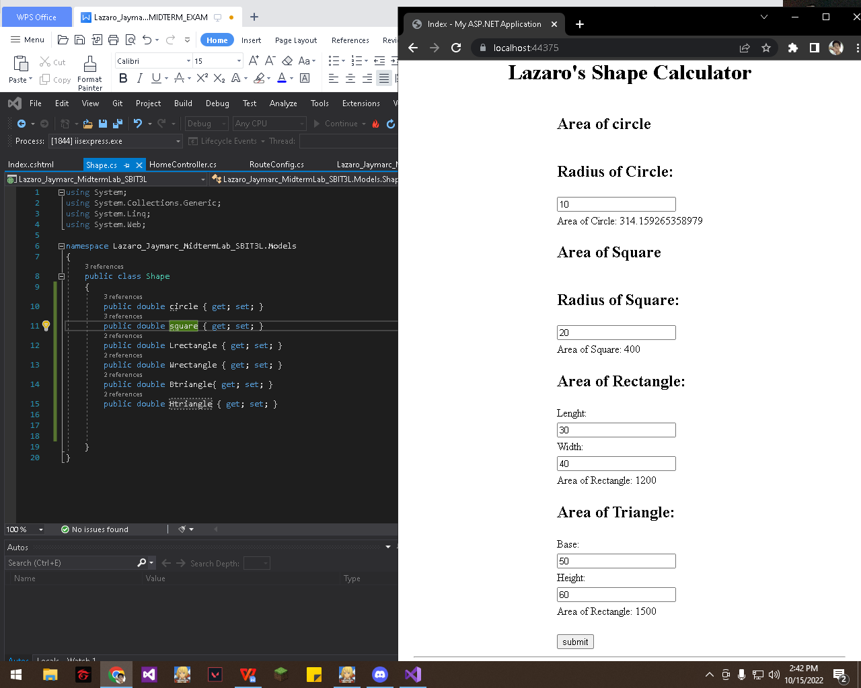

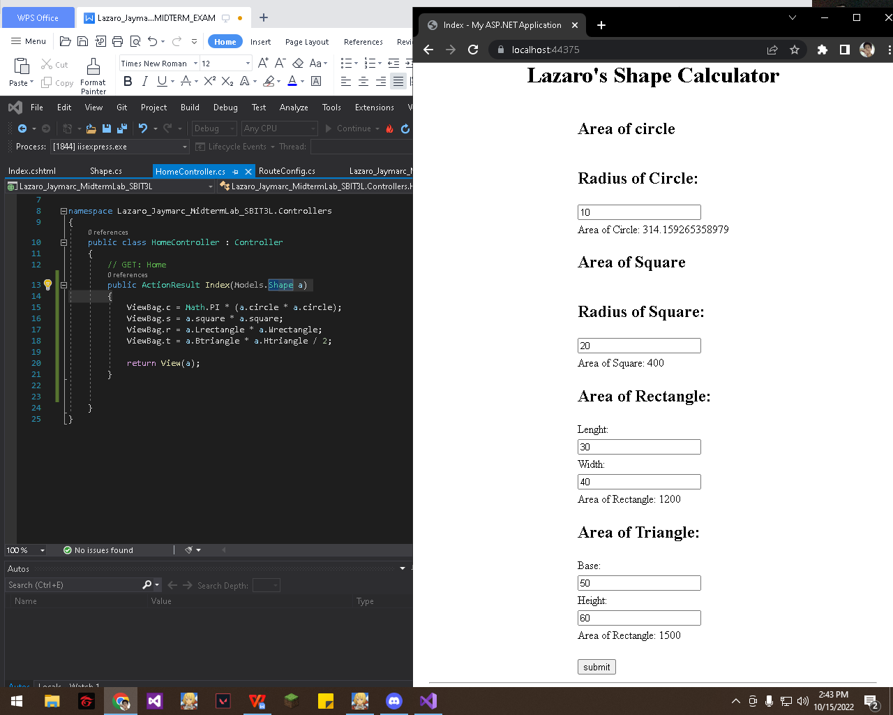

Index.cshtml

@{

ViewBag.Title = "Index";

}

@model Lazaro_Jaymarc_MidtermLab_SBIT3L.Models.Shape

<center><h1>Lazaro's Shape Calculator</h1></center>

@using (Html.BeginForm())

{

<center>

<table>

<tr>

<td>

<h2>

Area of circle

</h2>

</td>

</tr>

<tr>

<td>

<h2>

Radius of Circle:

</h2>

</td>

</tr>

<tr>

<td>

@Html.TextBoxFor(a => a.circle)

</td>

</tr>

<tr>

<td>

Area of Circle: @ViewBag.c <br />

</td>

</tr>

<tr>

<td>

<h2>

Area of Square

</h2>

</td>

</tr>

<tr>

<td>

<h2>

Radius of Square:

</h2>

</td>

</tr>

<tr>

<td>

@Html.TextBoxFor(a => a.square)

</td>

</tr>

<tr>

<td>

Area of Square: @ViewBag.s <br />

</td>

</tr>

<tr>

<td>

<h2>

Area of Rectangle:

</h2>

</td>

</tr>

<tr>

<td>

Lenght:

</td>

</tr>

<tr>

<td>

@Html.TextBoxFor(a => a.Lrectangle)

</td>

</tr>

<tr>

<td>

Width:

</td>

</tr>

<tr>

<td>

@Html.TextBoxFor(a => a.Wrectangle)

</td>

</tr>

<tr>

<td>

Area of Rectangle: @ViewBag.r <br />

</td>

</tr>

<tr>

<td>

<h2>

Area of Triangle:

</h2>

</td>

</tr>

<tr>

<td>

Base:

</td>

</tr>

<tr>

<td>

@Html.TextBoxFor(a => a.Btriangle)

</td>

</tr>

<tr>

<td>

Height:

</td>

</tr>

<tr>

<td>

@Html.TextBoxFor(a => a.Htriangle)

</td>

</tr>

<tr>

<td>

Area of Rectangle: @ViewBag.t <br />

</td>

</tr>

<tr>

<td>

<br /> <input type="submit" value="submit" /> <br />

</td>

</tr>

</table>

</center>

}